1. Go to SE11. Create nested structure as shown below.

Note: Z104329NAME and Z104329ADDRESS are already created.

Refer to the Word Document DDIC Structure - Flat Structure Demo1 for creating the above.

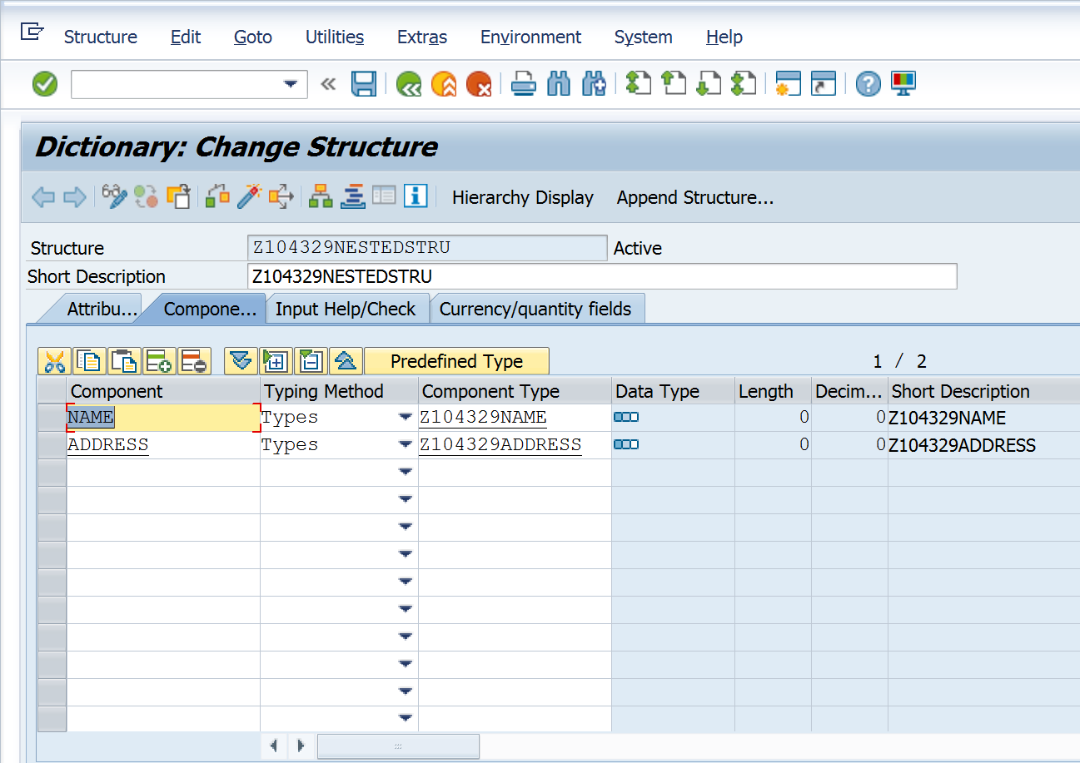

REPORT Z.   
DATA WA_NESTEDSTRU TYPE Z104329NESTEDSTRU.  
  
WA_NESTEDSTRU-NAME-FIRSTNAME = 'Hans'.  
WA_NESTEDSTRU-NAME-LASTNAME = 'Hans'.  
  
WA_NESTEDSTRU-ADDRESS-STREET = 'Neurott Str 15 a'.  
WA_NESTEDSTRU-ADDRESS-ZIPCODE  = 'D-69190'.  
WA_NESTEDSTRU-ADDRESS-CITY  =  'Walldrof'.  
  
WRITE :/  WA_NESTEDSTRU-NAME-FIRSTNAME,  
          WA_NESTEDSTRU-NAME-LASTNAME,  
          WA_NESTEDSTRU-ADDRESS-CITY,  
          WA_NESTEDSTRU-ADDRESS-STREET,  
          WA_NESTEDSTRU-ADDRESS-ZIPCODE.   
            
          